2011
Texas Archery Academy

Tony Fontana

Making a PVC practice bow
This document demonstrates how to construct an archery practice bow out of ordinary ½ inch SCH 40 PVC pipe.

Introduction
There are many devices that can help an archer develop their form. The PVC bow is one of the best that I know of. I have been using them to teach students for many years. It is also one of the cheapest to make, around $1.25.
Warning
This is not a real bow and no attempt should be made to use a real arrow with this practice bow. To make this bow requires working knowledge of hand tools, drills and heat sealing the ends of the rope. If you do not posses these skills, please find someone that can help you. We do not take any responsibility for your inability or injuries and make no warrantee on the results on making or using a PVC bow.
The PVC bow can be dry-fired repeatedly and it should not break. At least, I have never had one break, though I have heard of this occurring, please be careful.
Use ½ inch Sch 40 PVC pipe. You can purchase 10 foot lengths at Home Depot and Lowes for around $1.87.
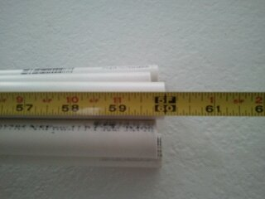
Cut into 60 inch lengths—longer if using it with a tall person. Most of the time, the store will have a PVC pipe cutter and will cut the pipe to the length you need at no charge.
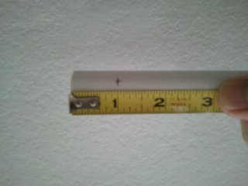
Note: PVC pipe will naturally bend when you apply pressure to one end of the pipe with the other end pressing against the floor. Mark the inside of this curve; it is the side you mark in the next step.
At both ends of the pipe, make a mark 1 inch from the end. The marks must be in line with each other and on the inside of the natural curve of the pipe.
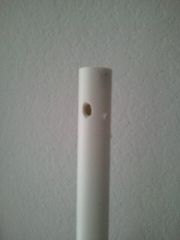
Drill a 3/8 inch hole at the marked locations and slightly elongate the hole on the inside curve of the bow.
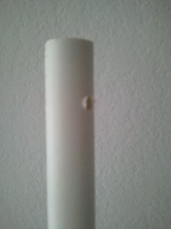
Clean off any burrs that occur after drilling the holes. Back-side of the hole had a burr, and can be very sharp. If you don’t remove these burrs it will cut through the string.
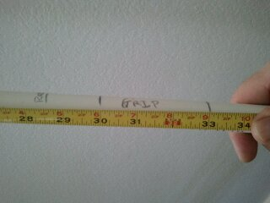
Mark the location of the grip, and arrow rest. The top of the grip is centered on the bow (30 inches for a 60” pipe). The bottom of the grip is at 3 inches below. The arrow rest is marked at 1.5 inches above the grip. I have not found any marker on the market that will make these marking permanent. I use a Sharpe and then cover with clear scotch tape.
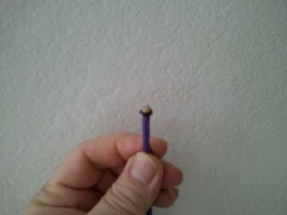
Cut a piece of string approximately 72 inches in length. Depending on the type of rope you use this may be different because it will stretch differently. The type I use stretches a lot. I use a polypropylene clothes line from Home Depot. It comes is a variety of colors and cost $2.97 for 50 yards. After cutting the rope, heat the end to melt it into a small ball. This is to prevent the end from fraying. If you are using a cotton clothes line this step is omitted, as the cotton will not melt.
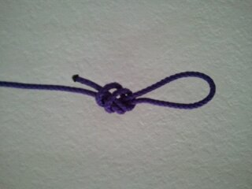
Make a loop at both ends of the rope. The loop should be just large enough to fit around the pipe once threaded through the holes in the end of the pipe.
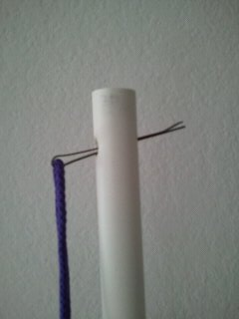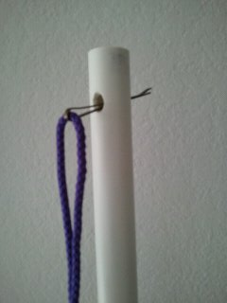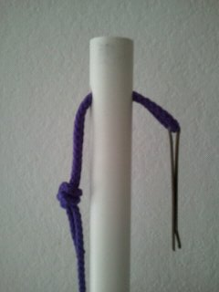
Using a hair pin or other device, thread the rope through the pipe starting on the inside curve, the side with the elongated hole.
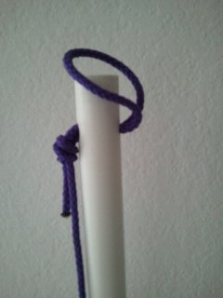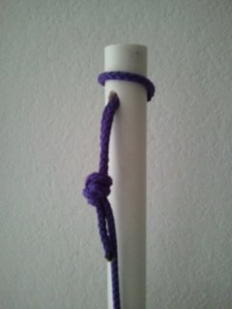
Loop the end of the rope over the end of the pipe. And pull tight.
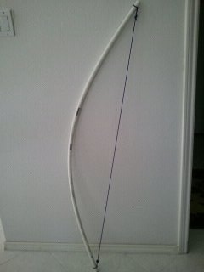
Use a bow square to mark the nock location. If you don’t have a square just estimate the nock location opposite the arrow rest position. I use a permanent marker to mark the string. Others have used serving thread, a brass nock, thread, etc. This should be at the same height as the arrow rest.
Final Notes:
Don’t forget to stretch the string a bunch of times while on the bow. This will lower the brace height. Adjust the length of the end-loop small amounts to increase or reduce the brace height. If it is to low the string will slap the wrist when released. Ouch!!!
I have added D-loops to help Compound shooters learn form. You can create a D-loop with more of the same string.
I have also added a sight ring to a few bows. This helps when teaching sighting principles. I will add the steps on “how to” do this in my next edition.

